Project Report Template

# INTRODUCTION

* 1. Keerthi sweets

Visually useful for party sharing their happiness with delicious sweets

* 1. Purpose

Party treat &festival time customer buy and share their sweets with happiness

1. **Keerthi sweets sale improvement idea & Thinking**
   1. Empathy Map

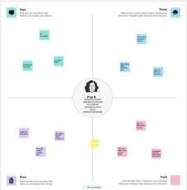

* 1. 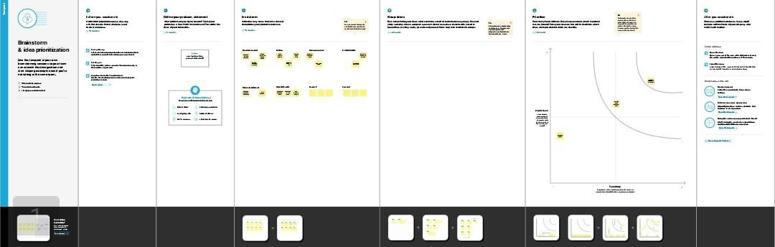Ideation & Brainstorming Map

# RESULT



1. **ADVANTAGES & DISADVANTAGES**

It will be lowers blood pressure,&boots happiness and mental health

Its disadvantage sugar makes your organs fat

It turns you into an addict

# APPLICATIONS

# It will be the token of appreciation.it will be useful for students career.

# CONCLUSION

We Learn a lot of New things about Editing and make it useful for others.